Part 1

Case Study 2

1NF

|  |  |  |  |  |  |
| --- | --- | --- | --- | --- | --- |
| Order Num | Line | Item Number | Description | Qty Ordered | Price Each |
| 106 | 1 | FA-10000 | Bicycle Model 30,26" | 100 | $ 280.00 |
| 106 | 2 | TA-50000 | Tire 26" Tubeless | 100 | $ 15.00 |
| 106 | 3 | TA-60000 | Hub, Wheel 32" Hole | 200 | $ 4.00 |
| 108 | 1 | AL-10000 | Steel,Chromium | 10 | $ 3.85 |
| 108 | 2 | CG-10000 | Grips,Cushioned | 200 | $ 2.50 |
| 109 | 2 | CP-15000 | Seat,Deluxe | 1500 | $ 8.00 |
| 109 | 1 | FA-20000 | Bicycle,Model-50,26" | 200 | $ 320.00 |
| 109 | 4 | TA-50000 | Tire,26",Tubeless | 1000 | $ 30.00 |
| 109 | 3 | TA-60000 | Hub, Wheel 32" Hole | 400 | $8.00 |
| 110 | 4 | CP-15000 | Seat,Deluxe | 100 | $ 4.00 |
| 110 | 1 | FA-10000 | Bicycle,Model-30,26" | 250 | $ 280.00 |
| 110 | 2 | FA-20000 | Bicycle,Model-50,26" | 50 | $ 320.00 |
| 110 | 3 | FA-30000 | Bicycle,Model-100,700mm,Eurocycle | 150 | $ 450.00 |
| 116 | 5 | CP-10000 | Seat,Padded | 50 | $ 2.30 |
| 116 | 3 | CP-15000 | Seat,Deluxe | 50 | $ 5.00 |
| 116 | 1 | FA-10000 | Bicycle,Model-30,26" | 100 | $ 290.00 |
| 116 | 2 | FA-20000 | Bicycle,Model-50,26" | 50 | $ 320.00 |
| 116 | 4 | TA-50000 | Tire,26",Tubeless | 25 | $ 20.00 |
| 134 | 2 | FA-20000 | Bicycle,Model-50,26" | 15 | $ 350.00 |
| 134 | 1 | FA-30000 | Bicycle,Model-100,700mm,Eurocycle | 20 | $ 450.00 |

OrderItem(**Order Num, Line**, Item Number, Description, Qty Ordered, Price Each)

2NF

|  |  |  |  |  |  |  |  |
| --- | --- | --- | --- | --- | --- | --- | --- |
| Order Num | Line | Qty Ordered |  |  | Item Number | Description - Foreign Key | Price Each |
| 106 | 1 | 100 |  |  | FA-10000 | Bicycle Model 30,26" | $ 280.00 |
| 106 | 2 | 100 |  |  | FA-30000 | Bicycle,Model-100,700mm,Eurocycle | $ 450.00 |
| 106 | 3 | 200 |  |  | FA-30000 | Bicycle,Model-100,700mm,Eurocycle | $ 450.00 |
| 108 | 1 | 10 |  |  | FA-10000 | Bicycle,Model-30,26" | $ 280.00 |
| 108 | 2 | 200 |  |  | FA-10000 | Bicycle,Model-30,26" | $ 290.00 |
| 109 | 2 | 1500 |  |  | FA-20000 | Bicycle,Model-50,26" | $ 320.00 |
| 109 | 1 | 200 |  |  | FA-20000 | Bicycle,Model-50,26" | $ 320.00 |
| 109 | 4 | 1000 |  |  | FA-20000 | Bicycle,Model-50,26" | $ 320.00 |
| 109 | 3 | 400 |  |  | FA-20000 | Bicycle,Model-50,26" | $ 350.00 |
| 110 | 4 | 100 |  |  | CG-10000 | Grips,Cushioned | $ 2.50 |
| 110 | 1 | 250 |  |  | TA-60000 | Hub, Wheel 32" Hole | $ 4.00 |
| 110 | 2 | 50 |  |  | TA-60000 | Hub, Wheel 32" Hole | $8.00 |
| 110 | 3 | 150 |  |  | CP-15000 | Seat,Deluxe | $ 8.00 |
| 116 | 5 | 50 |  |  | CP-15000 | Seat,Deluxe | $ 4.00 |
| 116 | 3 | 50 |  |  | CP-15000 | Seat,Deluxe | $ 5.00 |
| 116 | 1 | 100 |  |  | CP-10000 | Seat,Padded | $ 2.30 |
| 116 | 2 | 50 |  |  | AL-10000 | Steel,Chromium | $ 3.85 |
| 116 | 4 | 25 |  |  | TA-50000 | Tire 26" Tubeless | $ 15.00 |
| 134 | 2 | 15 |  |  | TA-50000 | Tire,26",Tubeless | $ 30.00 |
| 134 | 1 | 20 |  |  | TA-50000 | Tire,26",Tubeless | $ 20.00 |

OrderItem(**Order Num, Line**, Item Number, Qty Ordered)

ItemNumber(**ItemNumber**, Description, PriceEach)

Junction Table

OrderItem(**OrderNum, Line, ItemNumber**)

3NF

|  |  |  |  |  |  |  |  |  |
| --- | --- | --- | --- | --- | --- | --- | --- | --- |
| Order Num | Line | Qty Ordered |  | Item Number | Description - Foreign Key |  | Description - Foreign Key | Price Each |
| 106 | 1 | 100 |  | FA-10000 | Bicycle Model 30,26" |  | Bicycle Model 30,26" | $ 280.00 |
| 106 | 2 | 100 |  | FA-30000 | Bicycle,Model-100,700mm,Eurocycle |  | Bicycle,Model-100,700mm,Eurocycle | $ 450.00 |
| 106 | 3 | 200 |  | FA-30000 | Bicycle,Model-100,700mm,Eurocycle |  | Bicycle,Model-100,700mm,Eurocycle | $ 450.00 |
| 108 | 1 | 10 |  | FA-10000 | Bicycle,Model-30,26" |  | Bicycle,Model-30,26" | $ 280.00 |
| 108 | 2 | 200 |  | FA-10000 | Bicycle,Model-30,26" |  | Bicycle,Model-30,26" | $ 290.00 |
| 109 | 2 | 1500 |  | FA-20000 | Bicycle,Model-50,26" |  | Bicycle,Model-50,26" | $ 320.00 |
| 109 | 1 | 200 |  | FA-20000 | Bicycle,Model-50,26" |  | Bicycle,Model-50,26" | $ 320.00 |
| 109 | 4 | 1000 |  | FA-20000 | Bicycle,Model-50,26" |  | Bicycle,Model-50,26" | $ 320.00 |
| 109 | 3 | 400 |  | FA-20000 | Bicycle,Model-50,26" |  | Bicycle,Model-50,26" | $ 350.00 |
| 110 | 4 | 100 |  | CG-10000 | Grips,Cushioned |  | Grips,Cushioned | $ 2.50 |
| 110 | 1 | 250 |  | TA-60000 | Hub, Wheel 32" Hole |  | Hub, Wheel 32" Hole | $ 4.00 |
| 110 | 2 | 50 |  | TA-60000 | Hub, Wheel 32" Hole |  | Hub, Wheel 32" Hole | $8.00 |
| 110 | 3 | 150 |  | CP-15000 | Seat,Deluxe |  | Seat,Deluxe | $ 8.00 |
| 116 | 5 | 50 |  | CP-15000 | Seat,Deluxe |  | Seat,Deluxe | $ 4.00 |
| 116 | 3 | 50 |  | CP-15000 | Seat,Deluxe |  | Seat,Deluxe | $ 5.00 |
| 116 | 1 | 100 |  | CP-10000 | Seat,Padded |  | Seat,Padded | $ 2.30 |
| 116 | 2 | 50 |  | AL-10000 | Steel,Chromium |  | Steel,Chromium | $ 3.85 |
| 116 | 4 | 25 |  | TA-50000 | Tire 26" Tubeless |  | Tire 26" Tubeless | $ 15.00 |
| 134 | 2 | 15 |  | TA-50000 | Tire,26",Tubeless |  | Tire,26",Tubeless | $ 30.00 |
| 134 | 1 | 20 |  | TA-50000 | Tire,26",Tubeless |  | Tire,26",Tubeless | $ 20.00 |

OrderItem(**Order Num, Line,** Item Number, Qty Ordered)

ItemNumber**(ItemNumber**, Description)

Description(**Description**, PriceEach)

Case Study 3

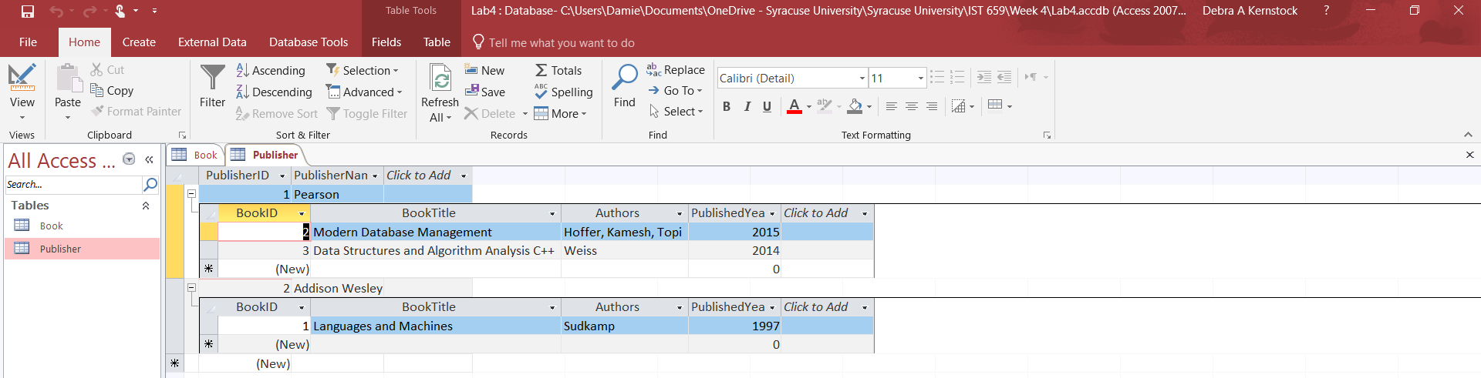

Have another look at the Book table. In what normal form is this? If not in 3NF, what would need to be done to make it 3NF?

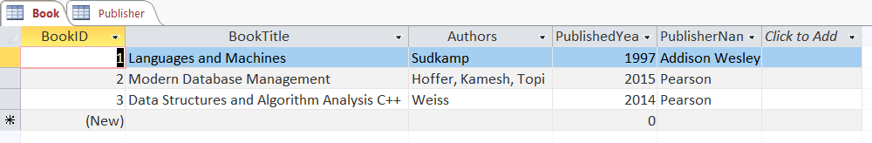

The book table is not in a normalized form.

To make it 1NF:

* Remove multivalued values in Authors

To make it 2NF:

* Create a separate table for BookTitles and Authors
* Create a separate table for BookTitles Publisher Year, and Publisher Name
* Create a Surrogate Key that links both tables together like Book Information

To make it 3NF:

* Have a table that has BookTitles and Authors 1:1
* Have a table that has BookTitles Publisher Year, and Publisher Name 1:1
* Create a table just for publishers name
* Link Publishers name to table for BookTitles Publisher Year, and Publisher Name

Part 2

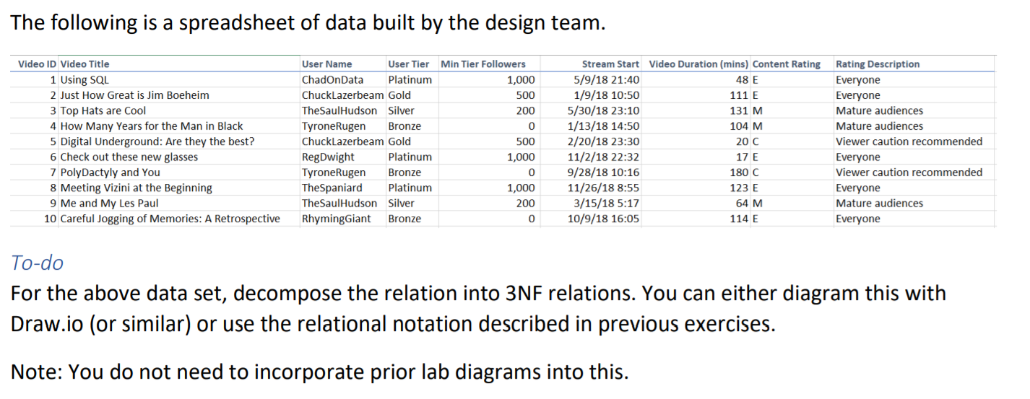

1NF

* Currently in 1NF

2NF

* Create new tables
  + **Video ID**, Video Title, Stream Start, Video Duration (mins)
  + **Username**, User Tier, Min Tier Followers
  + **Content Rating**, Rating Description

3NF

* Break down this table:
  + Video ID, Video Title, Stream Start, Video Duration (mins)
* Use the following tables
  + **Username,** User Tier, Min Tier Followers
  + **Content Rating**, Rating Description
* Create a new table
  + **Video ID**, Video Title
  + **Stream Start**, Video Duration (mins)